Ideation Phase
Define the Problem Statements

Date | 25 June 2026
Team ID
Project Name | Cab Booking Platform
Maximum Marks | 2 Marks

Customer Problem Statement Template:
Create a problem statement to understand your customer's point of view. The Customer Problem Statement template helps you focus on what matters to create experiences people will love.
A well-articulated customer problem statement allows you and your team to find the ideal solution for the challenges your customers face. Throughout the process, you’ll also be able to empathize with your customers, which helps you better understand how they perceive your product or service.

Reference: https://miro.com/templates/customer-problem-statement/
Example:

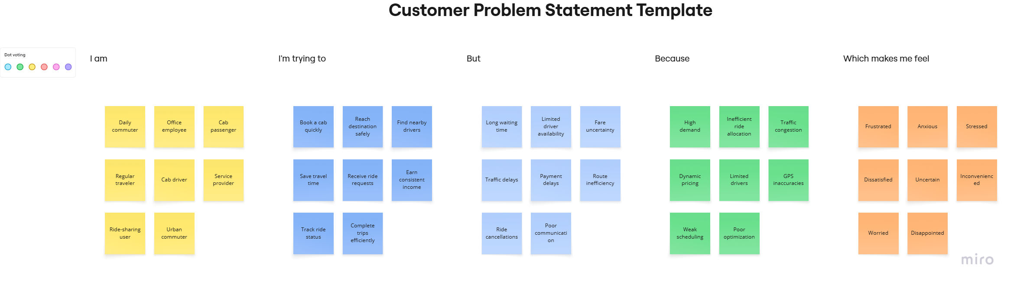

Problem Statement (PS) | I am (Customer) | I’m trying to | But | Because | Which makes me feel
PS-1 | A daily commuter who relies on cab services for work and personal travel. | Book a cab quickly and reach my destination safely and on time. | It is difficult to find available cabs, fare prices are sometimes unclear, and drivers may take longer than expected to arrive. | Existing cab booking services often have inefficient driver allocation, traffic delays, and inconsistent pricing. | Frustrated, anxious, and uncertain about reaching my destination on time.
PS-2 | A cab driver looking to earn a stable income through ride requests. | Receive ride requests consistently and manage my trips efficiently. | I sometimes receive fewer ride requests, face route inefficiencies, and experience delays in payments. | Existing systems do not always optimize ride allocation or provide transparent earnings management. | Stressed, dissatisfied, and concerned about my earnings.

